This Word module should be used for all taxonomic proposals.
Please complete Part 1 and:
either Part 3 for proposals to create new taxa or change existing taxa
or Part 2 for proposals of a general nature.
Submit the completed Word module, together with the accompanying Excel module named in Part 3, to the appropriate ICTV Subcommittee Chair.
The Word module explains and justifies your proposal. The Excel module is a critical document that will be used to implement the proposed taxonomic changes once they are approved and ratified. If proposals presented in the Word module are not presented accurately in the Excel module, the taxonomic changes cannot proceed.
For guidance, see the notes written in blue, below, and the Help Notes in file Taxonomic_Proposals_Help_2019.
Part 1: TITLE, AUTHORS, etc

Code assigned: | 2019.006G
Short title: Create a megataxonomic framework, filling all principal taxonomic ranks, for realm Riboviria
Author(s) and email address(es):
List authors in a single line Archives of Virology citation format (e.g. Smith AB, Huang C-L, Santos, F) |  | Provide email address for each author in a single line separated by semi-colons
Koonin EV, Dolja VV, Krupovic M, Varsani A, Wolf YI, Yutin N, Zerbini M, Kuhn JH |  | koonin@ncbi.nlm.nih.gov; doljav@science.oregonstate.edu; mart.krupovic@pasteur.fr; Arvind.Varsani@asu.edu;  wolf@ncbi.nlm.nih.gov;  yutin@ncbi.nlm.nih.gov;  zerbini@ufv.br; kuhnjens@mail.nih.gov
Corresponding authors
Koonin, Eugene V.; koonin@ncbi.nlm.nih.gov
Kuhn, Jens H.; kuhnjens@mail.nih.gov
List the ICTV study group(s) that have seen this proposal:
A list of study groups and contacts is provided at http://www.ictvonline.org/subcommittees.asp . If in doubt, contact the appropriate subcommittee chair (there are six virus subcommittees: animal DNA and retroviruses, animal ssRNA-, animal ssRNA+, fungal and protist, plant, bacterial and archaeal) |  | ICTV Alphatetraviridae, Amalgaviridae, Arenaviridae, Artoviridae, Aspiviridae, Astroviridae, Barnaviridae, Bornaviridae, Botourmiaviridae, Bromoviridae, Bunyavirales, Caliciviridae, Carmotetraviridae, Caulimoviridae, Chrysoviridae, Closteroviridae, Cystoviridae, Endornaviridae, Filoviridae, Fimoviridae, Flaviviridae, Hantaviridae, Hepadnaviridae, Hepeviridae, Hypoviridae, Leviviridae, Luteoviridae, Monjiviricetes, Mymonaviridae, Nairoviridae, Narnaviridae, Negarnaviricota, Nidovirales, Nodaviridae, Nyamiviridae, Orthomyxoviridae, Paramyxoviridae, Partitiviridae, Peribunyaviridae, Picobirnaviridae, Phasmaviridae, Phenuiviridae, Picornavirales, Pneumoviridae, Potyviridae, Reoviridae, Retroviridae, Rhabdoviridae, Sobemovirus, Tenuivirus, Togaviridae, Tombusviridae, Tospoviridae, Totiviridae, Tymoviridae, and Virgaviridae Study Group Chairs, ICTV Bacterial and Archaeal Viruses Subcommittee; ICTV Animal dsRNA and ssRNA- Viruses Subcommittee Chair; ICTV Animal DNA Viruses and Retroviruses Subcommittee Chair; ICTV Plant Viruses Subcommittee Chair; ICTV Fungal and Protist Viruses Subcommittee Chair  This is a direct submission to the entire ICTV Executive Committee
ICTV Study Group/Author comments (if any) and response of the proposer:
Here we propose a megataxonomic framework for the only currently established viral realm, Riboviria, by assigning ICTV-ratified taxa (i.e., species, genera, subfamilies, families, orders, and one phylum) to available, but presently unfilled major megataxonomic ranks (orders, classes, phyla, and kingdoms). The goal of this proposal is to provide taxonomic “buckets” or “place holders” that enable ICTV Study Groups to accommodate the close-to-exponentially increasing number of novel viruses that are related to, but distinct from, viruses that constitute the already established taxa. The awareness of these novel viruses often goes hand-in-hand with the realization that current orders might have to be promoted to orders(e.g., Reoviridae) or that entire family structures need to be completely re-evaluated (e.g., Orthomyxoviridae). We surmise that the absence of established higher taxa and the absence of ICTV Study Groups for such taxa may have had an adverse effect, leading to large groups of classifiable viruses not becoming classified. Vice versa, placing currently established taxa together into higher-rank taxa may initiate long-overdue, likely intense, discussions between currently non-interacting ICTV Study Groups to examine higher-rank evolutionary relationships of the viruses they are engaged with. The megataxonomy outlined in this proposal is to be seen only as an initial step and we fully expect this framework to change substantially over time.

We:
- aim to bring virus taxonomy into better accordance with other biological taxonomies, which require novel organisms to be classified into all available principle/primary ranks even if this means that certain higher-ranked taxa only include single lower-ranked taxa. For instance, in animal taxonomy, the unranked supergroup Hemimastigophora includes a single class Hemimastigidea, which includes a single order Hemimastigida, which includes a single family Spironem(atelli)idae (which includes 4 genera). Likewise, in prokaryotic taxonomy, the bacterial species Elusimicrobium minutum is the only included species in genus Elusimicrobium, which is the only genus in family Elusimicrobiaceae, which is the only family in order Elusimicrobiales—that order is the only order in class Elusimicrobia, which is the only class in phylum Elusimicrobia. Obviously, taxon demarcation criteria cannot be established for single taxon-including higher-ranked taxa and hence their definitions are identical to those of the higher-ranked taxa for the time being, i.e., until the discovery of novel organisms requires the creation of sister taxa. However, filling all principle ranks provides a sense of “scaling”, i.e. a current assessment of how distant a particular organism is from other classified taxa; this “scaling” argument was used successfully previously in TaxoProps establishing the availability of taxonomic ranks above order and the establishment realm Riboviria;
- deliberately propose the creation of higher-ranked taxa that currently include only single lower-ranked taxa, either because we are aware from the literature that an existing lower-rank taxon will have to be promoted to a higher rank in the near future due to overbearing virus diversity (e.g., Reoviridae), or because we are aware from the literature of large virus groups for which higher-rank taxa will have to be established shortly (e.g., “weiviruses”/“yanviruses”/”zhaoviruses”); we hope that the created higher-ranked taxa will provide an impetus for the community to classify already known highly divergent virus groups;
- deliberately did not fill any secondary (sub-)ranks as the filling of such ranks is not mandatory in other biological taxonomies;
- deliberately focus this proposal only on official taxa (rather than, for instance, proposing novel species that could become the founding members of “obvious” novel higher-rank taxa we are certain will need to be established) to keep this proposal relatively simple;
- emphasize that, although we posit that RNA-directed RNA polymerase (RdRp)/RNA-directed DNA polymerases/reverse transcriptase (RTs) phylogenies are initially sufficient for creation of RNA virus megataxonomy (from the highest rank, realm, down to approximately class/order), such a focus must be seen as a rough guide for lower-rank taxonomy, so that other methods (e.g., sequence-based methods such as GRAViTy, pairwise genome sequence comparisons, phylogenies of individual ORFs or proteins; structural comparisons of encoded proteins or virions; phenotypic virus characteristics) will have to be used to resolve lower-rank relationships and likely to refine higher-rank relationships.
Date first submitted to ICTV: |  |  | June 19, 2019
Date of this revision (if different to above): |  |  | October 18, 2019

ICTV-EC comments and response of the proposer:
Per the minutes of the last ICTV Executive Committee meeting (EC51, July 15–17, 2019, Berlin, Germany), the EC voted for minor revisions of this proposal (Uc) with 12/19 votes in favor. The EC asked for the following steps to be taken prior to submission of this revision:
- Consult all affected Study Group once again for feedback

Response: all relevant Study Group Chairs were contacted for a second time and asked to provide input and criticisms. None of the Study Groups disagreed with the overall taxonomic proposal, i.e., the proposed relationship between officially established taxa. Concerns were voiced about certain proposed taxon names and the Study Groups’ suggestion were mostly followed and names were changed accordingly for this revision.

- Provide any feedback from Study Groups to the ICTV President

Response: all relevant Study Group responses (and all TaxoProp author rebuttals or explanations) were forwarded to the ICTV President and the ICTV Executive Committee per email.

- Regarding proposed taxon names using people’s names, provide permissions from these people (if alive) to use their names to the ICTV President and the ICTV Proposals Secretary

Response: all relevant permissions were forwarded to the ICTV President, the ICTV Proposal Secretary, and the ICTV Executive Committee per email.

- Several ICTV Executive Committee members correctly pointed out that are paraphyletic clades within the realm, in particular the dsRNA virus clades in Branches 4–5.

Response: This issue had already been discussed in the literature [24]: this issue indeed needs to be resolved in the near future, but while the RdRp-tree suggests Branches 4 and 5 to be one clade rather than 2, the fundamentally different genomic organization of the dsRNA viruses compared to those in phylum Negarnaviricota and the conservation of the dsRNA virus CP structure and capsid organization, with 60 homo- or heterodimers of the CP organized on an unusual, so-called pseudo T=2 lattice, justifies, at least for now, to separate these two supergroups until further analysis are done using different genes and protein. One solution to this issue would be to create multiple phyla for dsRNA viruses (i.e., to dissolve Branch 4 into three separate branches/phyla), but this solution was considered too excessive by the coauthors at this point in time.

- Several ICTV Executive Committee members requested Figure 1 to be replaced with a new version showing expanded branches.

Response: done.

Part 3: PROPOSED TAXONOMY

Name of accompanying Excel module: 2019.006G.A.v1.Riboviria.xlsx

INTRODUCTION

Recent advances of comparative genomics and metagenomics uncover a close-to-exponentially increasing number of diverse viruses. These discoveries not only vastly improve our understanding of the evolutionary relationships within the virosphere, but also emphasize that the existing taxonomic framework is inadequate to depict the relationships within the virosphere. The currently available dataset of virus genome sequences and increasingly sophisticated methods for analysis beyond “simple” phylogenies (e.g., gene network analysis, iterative and self-optimizing sequence alignments) enable us now to roughly outline the global organization of the virus world in its entirety, including key evolutionary events that resulted in the emergence of major virus clades.

Depicting the evolutionary relationships among viruses necessarily depends on the identification of hallmark genes/proteins that connect them. In contrast to cellular organisms, such hallmark genes are not universally shared among all viruses [9] and it is therefore currently presumed that viruses have several distinct points of origin, i.e., that they cannot be united under a single highest taxon rank on evolutionary grounds. Nevertheless, extensive analyses of the evolution of large groups of viruses, rather than all of them, have proved productive. The primary approach taken in such studies is the phylogenetic analysis of genes that are conserved across those groups, known as Virus Hallmark Genes (VHGs), which are responsible for the key functions in virus replication and virion morphogenesis [9]. The most widely spread VHGs are:
- RNA-directed RNA polymerases (RdRps);
- RNA-directed DNA polymerases/reverse transcriptases (RTs) that are homologous to RdRps;
- superfamily 3 helicases (S3Hs);
- single jelly-roll major capsid proteins (SJR-MCPs);
- double jelly-roll major capsid proteins (DJR-MCPs); and
- rolling-circle replication initiation endonucleases (RCREs) [9, 11, 12].

Using these VHGs, megataxonomic scaffolds can be established that are further informed, if necessary, by dissection of bipartite gene-genome networks of viruses into distinct modules [4-6, 10, 21]. These analyses indicate that a substantial majority of currently classified viruses can be assigned to one of four, likely, evolutionarily independent virus realms. Because the International Committee on Taxonomy of Viruses (ICTV) has recently formally approved creation of taxa above the rank of order, the door is now open to formalize the megataxonomic scaffolds that resulted from VHG analyses within the official ICTV-supported taxonomy.

Here we propose a megataxonomic structure for one of these groups: RNA and reverse-transcribing viruses.

MEGATAXONOMY OF Riboviria
Recently, all currently classified RNA viruses have been formally unified in a realm (Riboviria), the now highest officially available taxon rank supported by the ICTV [22]. The establishment of this realm was based on the realization that a) ranks higher than order will be needed to appropriately classify the increasing number of RNA viruses and b) on the logical need that any classification scheme needs to have a top and bottom between which all ranks must be situation (“crown of the tree”/species, “root of the tree”/realm) [5](TaxoProps 2017.006G by Gorbalenya et al.; and 2017.005G by Gorbalenya et al.). However, the creation of the realm was also justified because all then-classified RNA viruses could be connected via their major VHG encoding an RdRp or RT [6, 7]. One phylum, Negarnaviricota, was included in the realm encompassing all negative-sense RNA viruses with the exception of hepatitis D virus [13, 22]. However, this phylum was not assigned to a kingdom, and all other RNA viruses were not assigned to any higher rank.

Comparison of RdRp/RT sequences and of the structures of these polymerases from diverse RNA viruses and retroelements revealed the monophyly of these enzymes [24, 26]. The RdRp/RT phylogenetic trees, in which the most highly conserved RTs (group II introns) are included as the outgroup, have a well-defined structure that were published previously [24, 25]. The monophyly of the two main groups (RdRp viruses and RT viruses, here proposed to be kingdoms) and the five RdRp branches (here proposed to be phyla) is strongly supported by the used sequence data analysis [24] (Figures 1 and 2), whereas the relationships between the branches are much less clear.

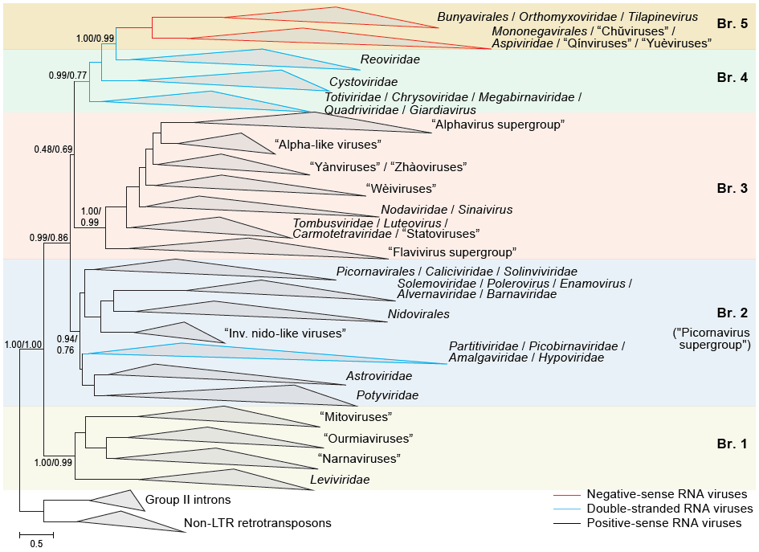

Figure 1. Phylogeny of RdRps of RNA viruses (Riboviria, proposed kingdom Orthornavirae): each of the 5 main branches (proposed to represent 5 distinct phyla) represents collapsed sequences of the corresponding set of RdRps (for details and methods see [24]).

RdRp VIRUSES (PROPOSED KINGDOM Orthornavirae)
Branch 1 (proposed phylum Lenarviricota)
Branch 1 is dominated by RdRps of prokaryotic (+)RNA viruses assigned to the Leviviridae and a dramatically increasing number of levivirid-like viruses, plus their apparent descendants that infect eukaryotes (viruses currently classified in Botourmiaviridae and Narnaviridae and their immediate relatives that already outnumber classified viruses). Based on the phylogenetic tree, we propose the creation of four classes for levivirids and relatives, narnaviruses and relatives, mitoviruses and relatives (removed from Narnaviridae), and botourmiavirids and relatives, respectively.

Branch 2 (proposed phylum Pisuviricota)
Branch 2 of the RdRp tree represents what is sometimes referred to as the “picornavirus supergroup” [4, 7-9], which includes the large established orders Nidovirales and Picornavirales. The most notable features of this branch is the interleaving of a clade of bipartite dsRNA viruses that includes Partitiviridae and (likely prokaryotic) Picobirnaviridae embedded among (+)RNA viruses [24], and the inclusion of Amalgaviridae, a family of dsRNA viruses infecting plants and protists that encode an RdRp confidently affined with that of partitivirids but a capsid protein derived from nucleocapsid proteins of (-)RNA viruses of the Phenuiviridae [10]. Based on the phylogenetic tree, we propose the creation of three classes for 1) Picornavirales (now including Caliciviridae and Solinviviridae), Nidovirales, Alvernaviridae, Barnaviridae, and Solemoviridae, 2) Astroviridae and Potyviridae, and 3) Amalgaviridae, Hypoviridae, Partitiviridae, and Picobirnaviridae.

Branch 3 (proposed phylum Kitrinoviricota)
Branch 3 of the RdRp tree consists of eukaryotic (+)RNA viruses representing what are often referred to as the “alphavirus supergroup” and “flavivirus supergroup” [3, 7, 8]. Apart from these supergroups, Branch 3 includes Tymovirales and an assortment of lineages that all represent short-genome viruses, such as Nodaviridae and Tombusviridae. Based on the phylogenetic tree, we propose the creation of four classes for 1) “flavivirus supergroup”: Flaviviridae and their rapidly increasing number of relatives, 2) Carmotetraviridae, Luteoviridae, and Tombusviridae, 3) Nodaviridae and Sinaivirus, and 4) “alphavirus supergroup”: Tymovirales, Alphatetraviridae, Benyviridae, Bromoviridae, Closteroviridae, Endornaviridae, Hepeviridae, Kitaviridae, Matonaviridae, Mayoviridae (proposed), Togaviridae, and Virgaviridae.

Branch 4 (proposed phylum Duplornaviricota)
Branch 4 of the RdRp tree exclusively represents dsRNA viruses. Apart from the RdRp tree topology, the key evidence that supports the monophyly of dsRNA viruses in Branch 4 is the conservation of the CP structure and capsid organization, with 60 homo- or heterodimers of the CP organized on an unusual, so-called pseudo T=2 lattice [15, 17]. Notably, this branch also includes the viruses of the family Cystoviridae, the only known dsRNA viruses that infect prokaryotes [16]. Based on the phylogenetic tree, we propose the creation of three classes for 1) Chrysoviridae, Megabirnaviridae, Quadriviridae, and Totiviridae, 2) Cystoviridae, and 3) Reoviridae.

Branch 5 (Negarnaviricota)
This phylum is already established.

RT VIRUSES (PROPOSED KINGDOM Pararnavirae)
The phylogenetic tree of RTs consists of five major branches, four of which include non-viral retroelements [2, 12]. The remaining, strongly supported branch encompasses all RT viruses, which appear to have evolved from retrotransposons on a single occasion. The RT virus branch consists of four clades represented by currently established virus families: 1) Caulimoviridae/Metaviridae/Retroviridae, 2) Belpaoviridae, 3) Pseudoviridae, and 4) Hepadnaviridae (Figure 2) [12, 14].

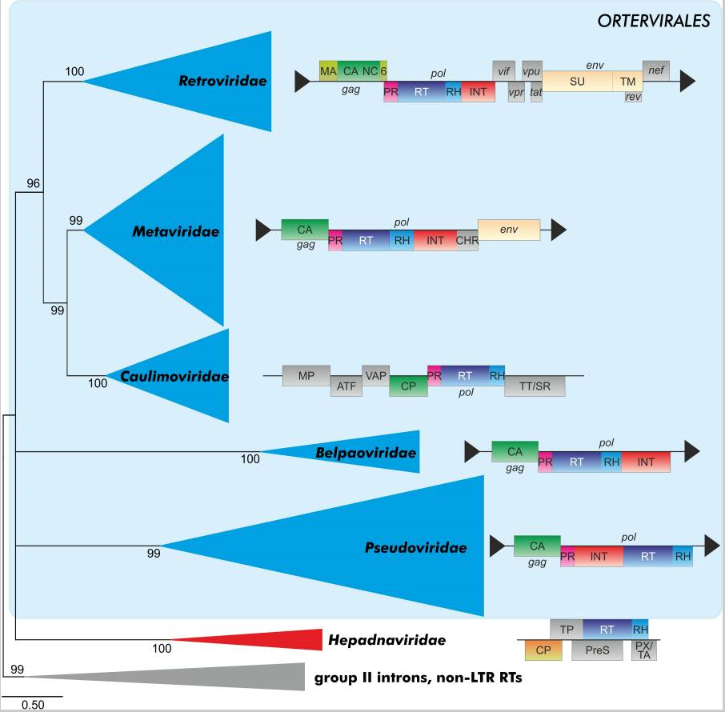
Figure 2. Maximum-likelihood phylogeny of virus RTs (for details and methods see [12]).

The genomes of viruses in all these families, except for hepadnavirids, share not only the RT gene but also genes encoding two core virion components, the capsid protein and nucleocapsid proteins (the latter apparently lost in spumaretrovirins) [11]. Because belpaovirids, caulimovirids (with dsDNA genomes), metavirids, pseudovirids, and retrovirids also share the same mechanism of replication priming, they already have been grouped in an order, Ortervirales [12]. In contrast, hepadnavirids use a protein-priming mechanism that is mediated by the terminal protein domain of the RT [14]. Although hepadnavirids package dsDNA genomes into their virions and have capsid proteins unrelated to those of Ortervirales, the monophyly of all viruses in the RT tree supports the grouping of ortervirals with hepadnavirids (proposed class Revtraviricetes included in proposed phylum Artverviricota).

This proposal is to be considered as an operational move to formalize an obvious relationship between the mentioned DNA viruses based on common VHGs.

VIRUSES OF UNCLEAR AFFILIATION
Until additional genomic data are acquired and detailed analyses are performed, we propose not to assign genus Deltavirus to the realm Riboviria; to keep taxa Albetovirus, Aumaivirus, Papanivirus, Sarthroviridae, and Virtovirus unassigned to higher-ranked taxa within realm Riboviria; and to assign Birnaviridae, Botybirnavirus, Permutotetraviridae, and Polymycoviridae [proposed] to kingdom Orthornavirae but to leave them unassigned to higher ranks within this kingdom.

Taxon demarcation criteria:
The International Code of Virus Classification and Nomenclature (ICVCN) is currently ambiguous regarding the need for taxon demarcation criteria at higher ranks. Three Rules appear to be applicable (emphasis in italics is ours):

“3.5 Taxa will be established only when representative member viruses are sufficiently well characterized and described in the published literature so as to allow them to be identified unambiguously and the taxon to be distinguished from other similar taxa”;

“3.22 Every individual virus is a physical entity and treated as belonging to a number of taxa of hierarchical ranks, some of which may remain undefined”;

and

“3.24 The classification of a virus at the species and genus ranks is mandatory. Classification may also encompass any further number of taxa at higher hierarchical ranks”

Because our proposal only encompasses already established taxa, all viruses affected by our proposal have been “sufficiently well characterized” as otherwise they would not have been classified into these established taxa in the first place. Furthermore, Rule 3.22 permits establishing ranks that for the moment remain undefined; and Rule 3.24 indicates no restriction of ranks to be established.

Overall, the taxon demarcation of high taxonomic ranks (order rank or higher) is for now defined by the phylogenetic trees. In addition, for the time being, we suggest the following additional provisional taxon demarcation criteria for some major taxa while being aware that these may have to be revisited whenever new members of the realm are being proposed:

- Riboviria: a virus is a member of this realm if encodes an RT or an RdRp
- Orthornavirae: a Riboviria member is a member of included kingdom Orthornavirae if it has an RNA genome and encodes an RdRp
- Lenarviricota: an Orthornavirae member is a member of included phylum Lenarviricota if it has a positive-sense RNA genome and infects prokaryotes, and does not cluster in RdRp trees with members of Kitrinoviricota
- Pisuviricota: an Orthornavirae member is a member of included phylum Pisuviricota if it has a positive-sense or double-stranded RNA genome and does not infect prokaryotes
- Kitrinoviricota: an Orthornavirae member is a member of included phylum Kitrinoviricota if it has a positive-sense, does not infect prokaryotes, and does not cluster in RdRp trees with members of Pisuviricota
- Duplornaviricota: an Orthornavirae member is a member of included phylum Duplornaviricota if it has a double-stranded RNA genome, infect prokaryotes or eukaryotes, does not cluster with members of Pisuviricota, and encodes a capsid composed of 60 homo- or heterodimers of capsid protein organized on an unusual, so-called pseudo T = 2 lattice
- Negarnaviricota: an Orthornavirae member is a member of included phylum Negarnaviricota if it has a negative-sense RNA genome
- Pararnavirae: a Riboviria member is a member of included kingdom Orthornavirae if it encodes an RT
- Blubervirales: a Pararnavirae member is a member of included order Blubervirales if it does not use tRNA molecules as primers for reverse transcription as members of order Ortervirales, but uses a protein-priming mechanism that is mediated by the terminal protein domain of the RT

If a principle rank taxon includes only a single lower-ranked taxon, then the definition of the lower-ranked taxon is, for now, identical to the definition of the higher-ranked taxon.

Truly useful taxon demarcation criteria will have to be established in the future, likely by incorporating yet-unclassified virus groups into the realm.

ETYMOLOGY OF PROPOSED TAXA
- Orthornavirae; from Greek ὀρθός [orthós] meaning straight; and the suffix -virae for kingdom taxa
- Lenarviricota; a portmanteau of Leviviridae and Narnaviridae; and the suffix -viricota for phylum taxa
- Allassoviricetes; from Greek αλλάσσω [allásso] meaning mutate (a reference to the high mutation rate of levivirids); and the suffix -viricetes for class taxa
- Levivirales; after Leviviridae, assuming that Leviviridae will have to promoted shortly to accommodate the rapidly expanding diversity of this taxon; and the suffix -virales for order taxa
- Howeltoviricetes; after Howell Township, New Jersey, USA, where a fungus (Cryphonectria parasitica) was isolated that was infected with the type mitovirus, [19]; and the suffix -viricetes for class taxa
- Cryppavirales; a portmanteau of Cryphonectra parasitica, the species of the fungus in which the first mitovirus was discovered; and the suffix -virales for order taxa
- Mitoviridae; after Mitovirus; and the suffix -viridae for family taxa
- Miaviricetes; from ourmiavirus; and the suffix -viricetes for class taxa
- Ourlivirales; a portmanteau of ourmiavirus-like; and the suffix -virales for order taxa
- Amabiliviricetes; after Zulu amabili meaning twenty, a reference to W/20S RNA of baker’s yeast (Saccharomyces cerevisiae), which turned out to be an RNA-directed RNA polymerase [18, 20]); and the suffix -viricetes for class taxa
- Wolframvirales; a tongue-in-cheek reference to the element wolfram, which is abbreviated W: the type narnavirus was found after sequencing “W dsRNA” in baker’s yeast (Saccharomyces cerevisiae); and the suffix -virales for order taxa
- Pisuviricota; a portmanteau of “picornavirus supergroup”; and the suffix -viricota for phylum taxa
- Pisoniviricetes; a portmanteau of the names of the founding orders (Picornavirales, Sobelivirales, Nidovirales); and the suffix -viricetes for class taxa
- Sobelivirales: a portmanteau of sobemovirus-like; and the suffix -virales for order taxa
- Stelpaviricetes; a portmanteau of the names of the founding orders (Stellavirales, Patatavirales); and the suffix -viricetes for class taxa
- Patatavirales; from Italian patata meaning potato, a reference to potato virus Y; and the suffix -virales for order taxa
- Stellavirales; from Latin stella meaning star (a reference to astroviruses—astro also means star); and the suffix -virales for order taxa
- Duplopiviricetes; from Italian duplo meaning double (a reference to double-stranded RNA) and the first two letters of picobirnaviruses; and the suffix -viricetes for class taxa
- Durnavirales; from Italian duplo meaning double (a reference to double-stranded RNA) and RNA; and the suffix -virales for order taxa
- Kitrinoviricota; after Greek κίτρινος [kítrinos] meaning yellow, a reference to yellow fever virus; and the suffix -viricota for phylum taxa
- Flasuviricetes; a portmanteau of “flavivirus supergroup”; and the suffix -viricetes for class taxa
- Amarillovirales; from Spanish amarillo meaning yellow, a reference to yellow fever virus; and the suffix -virales for order taxa
- Tolucaviricetes; a portmanteau of tombusviruses, luteoviruses, and carmotetraviruses; and the suffix -viricetes for class taxa
- Tolivirales; a portmanteau of tombusvirus-like; and the suffix -virales for order taxa
- Magsaviricetes; from Mag 115, the original designation of Nodamura virus, and Saitama Prefecture, Japan, where studies were performed that led to the discovery of Mag 115/Nodamura virus [21] ; and the suffix -viricetes for class taxa
- Nodamuvirales; a contraction of Nodamura virus; and the suffix -virales for order taxa
- Sinhaliviridae; a portmanteau of Sinaivirus and Halictivirus; and the suffix -viridae for family taxa
- Alsuviricetes; a portmanteau of “alphavirus supergroup”; and the suffix -viricetes for class taxa
- Martellivirales; a reference to G. P. Martelli, a pioneer in closterovirid research, and a long-time ICTV EC Member and two-mandate ICTV Plant Virus SC Chair; and the suffix -virales for order taxa
- Hepelivirales; a portmanteau of hepevirus-like; and the suffix -virales for order taxa
- Duplornaviricota; from Italian duplo meaning double (a reference to double-stranded RNA) and RNA; and the suffix -viricota for phylum taxa
- Chrymotiviricetes: a portmanteau of chrysovirus, megabirnavirus, and totivirus; and the suffix -viricetes for class taxa
- Ghabrivirales; in honor of the late Said Ghabrial†, a pioneer in study of the viruses in this order and former ICTV Subcommittee Chair for Fungal and Protist viruses; and the suffix -virales for order taxa
- Vidaverviricetes; in honor of Anne K. Vidaver, who co-discovered Pseudomonas phage phi6 [23]; and the suffix -viricetes for class taxa
- Mindivirales; a reference to Leonard Mindich, who contributed significantly to cystovirid research; and the suffix -virales for order taxa
- Resentoviricetes; derived from respiratory enteric orphan (also the phrase that gave rise to the word stem reo in reoviruses); and the suffix -viricetes for class taxa
- Reovirales; after Reovirales, assuming that Reoviridae will have to promoted shortly to accommodate the rapidly expanding diversity of this taxon; and the suffix -virales for order taxa
- Pararnavirae; from Greek παρά [pará] meaning besides/next to and RNA; and the suffix -virae for kingdom taxa
- Artverviricota; a portmanteau of reverse transcriptase read backwards; and the suffix -viricota for phylum taxa
- Revtraviricetes; a portmanteau of reverse transcriptase; and the suffix -viricetes for class taxa
- Blubervirales; in honor of Barry Blumberg† for his role in hepatitis B research [1]; and the suffix -virales for order taxa

Three of the proposed taxon names, Martellivirales, Vidaverviricetes, and Mindivirales are derived from the names of living persons. The permissions of these persons to use their names have been forwarded to the ICTV Executive Committee.

References:
1. Block TM, Alter HJ, London WT, Bray M (2016) A historical perspective on the discovery and elucidation of the hepatitis B virus. Antiviral Res 131:109-123
2. Gladyshev EA, Arkhipova IR (2011) A widespread class of reverse transcriptase-related cellular genes. Proc Natl Acad Sci U S A 108:20311-20316
3. Goldbach R (1987) Genome similarities between plant and animal RNA viruses. Microbiol Sci 4:197-202
4. Goldbach R, Wellink J (1988) Evolution of plus-strand RNA viruses. Intervirology 29:260-267
5. Gorbalenya AE (2018) Increasing the number of available ranks in virus taxonomy from five to ten and adopting the Baltimore classes as taxa at the basal rank. Arch Virol 163:2933-2936
6. Kamer G, Argos P (1984) Primary structural comparison of RNA-dependent polymerases from plant, animal and bacterial viruses. Nucleic Acids Res 12:7269-7282
7. Koonin EV (1991) The phylogeny of RNA-dependent RNA polymerases of positive-strand RNA viruses. J Gen Virol 72 ( Pt 9):2197-2206
8. Koonin EV, Dolja VV (1993) Evolution and taxonomy of positive-strand RNA viruses: implications of comparative analysis of amino acid sequences. Crit Rev Biochem Mol Biol 28:375-430
9. Koonin EV, Wolf YI, Nagasaki K, Dolja VV (2008) The Big Bang of picorna-like virus evolution antedates the radiation of eukaryotic supergroups. Nat Rev Microbiol 6:925-939
10. Krupovic M, Dolja VV, Koonin EV (2015) Plant viruses of the Amalgaviridae family evolved via recombination between viruses with double-stranded and negative-strand RNA genomes. Biol Direct 10:12
11. Krupovic M, Koonin EV (2017) Homologous capsid proteins testify to the common ancestry of retroviruses, caulimoviruses, pseudoviruses, and metaviruses. J Virol 91:e00210-00217
12. Krupovic M, Blomberg J, Coffin JM, Dasgupta I, Fan H, Geering AD, Gifford R, Harrach B, Hull R, Johnson W, Kreuze JF, Lindemann D, Llorens C, Lockhart B, Mayer J, Muller E, Olszewski NE, Pappu HR, Pooggin MM, Richert-Poggeler KR, Sabanadzovic S, Sanfacon H, Schoelz JE, Seal S, Stavolone L, Stoye JP, Teycheney PY, Tristem M, Koonin EV, Kuhn JH (2018) Ortervirales: new virus order unifying five families of reverse-transcribing viruses. J Virol 92:e00515-00518
13. Kuhn JH, Wolf YI, Krupovic M, Zhang YZ, Maes P, Dolja VV, Koonin EV (2019) Classify viruses - the gain is worth the pain. Nature 566:318-320
14. Lauber C, Seitz S, Mattei S, Suh A, Beck J, Herstein J, Borold J, Salzburger W, Kaderali L, Briggs JAG, Bartenschlager R (2017) Deciphering the origin and evolution of hepatitis B viruses by means of a family of non-enveloped fish viruses. Cell Host Microbe 22:387-399 e386
15. Luque D, Gomez-Blanco J, Garriga D, Brilot AF, Gonzalez JM, Havens WM, Carrascosa JL, Trus BL, Verdaguer N, Ghabrial SA, Caston JR (2014) Cryo-EM near-atomic structure of a dsRNA fungal virus shows ancient structural motifs preserved in the dsRNA viral lineage. Proc Natl Acad Sci U S A 111:7641-7646
16. Mantynen S, Sundberg LR, Poranen MM (2018) Recognition of six additional cystoviruses: Pseudomonas virus phi6 is no longer the sole species of the family Cystoviridae. Arch Virol 163:1117-1124
17. Mata CP, Luque D, Gomez-Blanco J, Rodriguez JM, Gonzalez JM, Suzuki N, Ghabrial SA, Carrascosa JL, Trus BL, Caston JR (2017) Acquisition of functions on the outer capsid surface during evolution of double-stranded RNA fungal viruses. PLoS Pathog 13:e1006755
18. Matsumoto Y, Wickner RB (1991) Yeast 20 S RNA replicon. Replication intermediates and encoded putative RNA polymerase. J Biol Chem 266:12779-12783
19. Polashock JJ, Hillman BI (1994) A small mitochondrial double-stranded (ds) RNA element associated with a hypovirulent strain of the chestnut blight fungus and ancestrally related to yeast cytoplasmic T and W dsRNAs. Proc Natl Acad Sci U S A 91:8680-8684
20. Rodriguez-Cousino N, Esteban LM, Esteban R (1991) Molecular cloning and characterization of W double-stranded RNA, a linear molecule present in Saccharomyces cerevisiae. Identification of its single-stranded RNA form as 20 S RNA. J Biol Chem 266:12772-12778
21. Scherer WF, Hurlbut HS (1967) Nodamura virus from Japan: a new and unusual arbovirus resistant to diethyl ether and chloroform. Am J Epidemiol 86:271-285
22. Siddell SG, Walker PJ, Lefkowitz EJ, Mushegian AR, Adams MJ, Dutilh BE, Gorbalenya AE, Harrach B, Harrison RL, Junglen S, Knowles NJ, Kropinski AM, Krupovic M, Kuhn JH, Nibert M, Rubino L, Sabanadzovic S, Sanfacon H, Simmonds P, Varsani A, Zerbini FM, Davison AJ (2019) Additional changes to taxonomy ratified in a special vote by the International Committee on Taxonomy of Viruses (October 2018). Arch Virol 164:943-946
23. Vidaver AK, Koski RK, Van Etten JL (1973) Bacteriophage phi6: a lipid-containing virus of Pseudomonas phaseolicola. J Virol 11:799-805
24. Wolf YI, Kazlauskas D, Iranzo J, Lucia-Sanz A, Kuhn JH, Krupovic M, Dolja VV, Koonin EV (2018) Origins and evolution of the global RNA virome. MBio 9:e02329-02318
25. Wolf YI, Kazlauskas D, Iranzo J, Lucia-Sanz A, Kuhn JH, Krupovic M, Dolja VV, Koonin EV (2019) Reply to Holmes and Duchene, "Can Sequence Phylogenies Safely Infer the Origin of the Global Virome?": deep phylogenetic analysis of RNA viruses is highly challenging but not meaningless. MBio 10:e00542-00519
26. Xiong Y, Eickbush TH (1990) Origin and evolution of retroelements based upon their reverse transcriptase sequences. EMBO J 9:3353-3362

