This form should be used for all taxonomic proposals. Please complete all those modules that are applicable.
For guidance, see the notes written in blue and the separate document “Help with completing a taxonomic proposal”

Please try to keep related proposals within a single document.

Part 1: TITLE, AUTHORS, etc

Code assigned: | 2017.006G |  |  |  | (to be completed by ICTV officers)
Short title: Riboviria: establishing a single taxon that comprises RNA viruses at the basal rank of virus taxonomy
Modules attached  (Modules 1, 4 and either 2 or 3 are required. |  | 1 2 3 4
Author(s):
Alexander E. Gorbalenya, Mart Krupovic, Stuart Siddell, Arvind Varsani, Jens H. Kuhn
Corresponding author with e-mail address:
Alexander E. Gorbalenya (a.e.gorbalenya@lumc.nl)
List the ICTV study group(s) that have seen this proposal:
A list of study groups and contacts is provided at http://www.ictvonline.org/subcommittees.asp . If in doubt, contact the appropriate subcommittee chair (there are six virus subcommittees: animal DNA and retroviruses, animal ssRNA-, animal ssRNA+, fungal and protist, plant, bacterial and archaeal) |  |  | The ICTV Executive Committee (EC) has already received an EC-commissioned Report about additional ranks in taxonomy from the authors of this proposal and two other EC colleagues. This report includes also a discussion of the merits of the matter of this proposal, which were first presented in the proposal 2016.003G.N.v1.VirusTaxonomyRanks, filed on August 4, 2016, and considered during the EC48 meeting. That original proposal along with the Report form the basis of this new proposal.
ICTV Study Group comments (if any) and response of the proposer:
ICTV-EC50 decision on Version #2: “Uc. (Conditions: provide better references, include already existing evidence for monophyly of all RNA viruses; add the RNA polymerase-based tree that is currently in the Negarnaviricota proposal, but relabel it to reflect the content of the current proposal.).”
Date first submitted to ICTV: |  |  |  | June 19, 2017
Date of this revision (version #2) (if different to above):  Date of this revision (version #3) (if different to above): |  |  |  | June 13, 2018  October 15, 2018

ICTV-EC comments and response of the proposer:
The revised version #3 of this TP addresses requests of EC50 to include references supporting monophyly of all RNA viruses.
The revised version #2 of this TP addresses criticisms and accommodates suggestions raised during electronic consultation with Chairs and Members of Study Groups concerned with diverse RNA viruses, which was conducted by Murilo Zerbini. It also takes into account the revision of the proposal on establishing additional ranks in taxonomy, 2017.005G.U.v4.AdditionalTaxonomyRanks, which was submitted on 28.05.2018. In summary, this revision updates the use of terms, resolves ambiguities, and clarifies the argumentation in favour of establishing the realm Riboviria.
Specifically, we have outlined the demarcation criterion for the membership of the Riboviria realm, addressed questions concerning the taxon monophyly, the impact of horizontal transfer, and the inclusion/exclusion of viruses using reverse transcriptase, which were raised by several colleagues. Also we explain the basis of the taxon name, and included the taxon name in the title of the proposal. The accompanying spreadsheet has not been updated.

Part 2: PROPOSED TAXONOMY
Present the proposed new taxonomy on accompanying spreadsheet
Name of accompanying spreadsheet: 2017.006G.N.v1.Riboviria
Please display the taxonomic changes you are proposing on the accompanying spreadsheet module 2017_TP_Template_Excel_module. Submit both this and the spreadsheet to the appropriate ICTV Subcommittee Chair.

Part 3: NON-STANDARD
Template for any proposal regarding ICTV procedures, rules or policy, not involving the creation of new taxonomy.

non-standard proposal
Title of proposal: Riboviria: establishing a single taxon that comprises RNA viruses at the basal rank of virus taxonomy
Text of proposal:
This proposal is connected to a recently revised proposal, submitted in parallel, in which the authors of this proposal together with Arcady Mushegian and Andrew M. Kropinski (the ART group, established by a decision of the EC48) propose the expansion of the current five-rank taxonomy structure of virus classification to a new structure that includes a total of 15 ranks. As a result of this proposed change, virus taxonomy will encompass the entire spectrum of virus diversity by accommodating taxa at any level of virus diversity from the very narrow (species; a terminal rank) to the extremely broad (realm; a basal rank).

To facilitate the use of the extended rank structure of virus taxonomy, as described in the ART group proposal, we now propose to establish at the basal "realm" rank, a taxon including RNA viruses that use cognate RNA-dependent RNA polymerases (RdRps) for replication. These viruses are highly diverse genetically, infect a wide range of prokaryotic and eukaryotic hosts, and comprise three classes of Baltimore classification [1]. The available data support, or are compatible with, the conclusion that all these viruses form a monophyletic lineage based on the RdRp palm domains [2, 4, 8-11, 13, 17]. The created taxon will convey a sense of scaling to the most distant relationships between viruses, which will be of assistance to authors of future proposals and the ICTV/EC as they consider the classification of highly divergent viruses, and will promote a link between taxonomy, other research fields and the classroom. Because of the exclusive RNA virus membership of this taxon and its basal rank, it is named Riboviria.

Our preferred approach to introducing taxa in virus taxonomy is by filling ranks encompassing ever greater diversity; first defining a taxon at the species rank and then at ranks of greater diversity, as feasible using the available data. This involves using methods familiar to the authors, with ranks beyond family being optional. When it is not feasible to create taxa at certain intermediate ranks, they may be left temporarily unassigned. This approach is used in this proposal. Accordingly, all established taxa of RNA viruses, from the ranks of species to order are assigned to the newly proposed taxon at the realm rank, with taxa at all other, intermediate ranks left to be defined in future proposals that focus on a specific taxon or taxa.

The authors believe that the creation of the Riboviria realm is a first step in using the newly updated rank structure of virus taxonomy, which facilitates the classification of viruses that are distantly related. As our understanding of virus diversity and evolution advances, the composition and the rank placement of the Riboviria realm and even its naming may be updated or revised accordingly. For instance, it is conceivable that the membership of this taxon may be extended to include RNA and DNA viruses that use cognate reverse transcriptase for genome replication, or even with other DNA viruses that originated from RNA viruses.

The Appendix in Module 4 describes in more detail the reasoning of this proposal. Its precursor 2016.003G.N.v1.VirusTaxonomyRanks has been published [7].

Part 4: APPENDIX: supporting material
additional material in support of this proposal

Defining the scale of virus diversity at basal ranks of virus taxonomy: consideration of the Baltimore classification and the rational for establishing the realm Riboviria

The authors of this proposal felt that it could be instructive for practitioners of taxonomy to have the basal rank, or basal proximal ranks of virus taxonomy, filled with one or more "virus groups". The choice and composition of these "virus groups" would convey a sense of scaling to virus diversity at these taxonomic levels, in the same way as assignment of virus isolates to a species defines the scaling of virus diversity at the opposite end of the taxonomy spectrum. The availability of this basal taxon would then assist authors of proposals concerned with establishing taxa at intermediate ranks. In this respect, the authors together with Arcady Mushegian and Andrew M. Kropinski (the ART group) devoted considerable time to discussing the merits of having Baltimore classes recognized as taxa at basal ranks, while acknowledging that this activity was not mandated by the original remit of the ART group at the EC48. The arguments for and against this move are summarized below.

Pro arguments:
- The Baltimore classification is found in most textbooks and taught along with virus taxonomy. Introducing Baltimore classes to the ICTV taxonomy would improve the accessibility and perceived relevance of virus taxonomy to students, researchers, and the public;
- Baltimore classes would convey a sense of scaling in a familiar and virus-specific context for all virologists;
- As with official virus taxonomy, the Baltimore classification partitions virus diversity into clusters (although formed purely on functional considerations related to genome expression);
- The Baltimore classification has only six or seven subdivisions (depending on the version; Figure 1), which is relatively few, as would be expected at the basal rank(s) of virus taxonomy; some Baltimore classes may be monophyletic or they may have a large monophyletic component;
- There is some similarity between Baltimore classes and the structure of ICTV Subcommittees, which was designed to reflect the major divisions of virus diversity.

Con arguments:
- The Baltimore classification was proposed in 1971 and may itself be in need of revision (compare, for example panels A and B of Figure 1), yet there is no established community-wide mechanism to introduce and approve changes to it;
- Several of the Baltimore classes are not monophyletic, defeating the purpose of their use in the context of phylogeny-guided virus taxonomy;
- The Baltimore classes are likely to have not originated simultaneously and thus may (and should) belong to different ranks;
- Certain monophyletic groups of viruses may traverse more than one Baltimore class.
- The number of Baltimore classes (taxa) exceeds that found at the basal rank of taxonomy of cellular organisms (two or three), although this argument is not applicable to basal proximal ranks;

After considering these arguments, the group concluded unanimously that the introduction of all existing Baltimore classes at the basal rank would be in conflict with major scientific findings, and the attraction of this familiar classification scheme does not outweigh the scientific concerns of its official adoption by ICTV (for more details, see 2017.005G.U.v4.AdditionalTaxonomyRanks)

Then, the authors of this proposal considered ways to include conceptual elements of the Baltimore classification into virus taxonomy. They considered each of the Baltimore classes that encompass RNA viruses separately and a group that consists of all Baltimore RNA virus classes combined. After discussions, it was agreed that RNA viruses using cognate RNA-dependent RNA polymerase (RdRp) (Figure 2; [18]) could be placed as a taxon in the basal realm rank. It includes viruses of the Baltimore classes III-V, which combined are likely to form a diverse monophyletic RdRp-based group, as briefly discussed below, whilst recognizing that some of the less ubiquitous protein domains that are found only in subsets of these viruses might have acquired through horizontal transfer (heterologous or illegitimate recombination) from other virus and/or cellular entities, as has been documented [5, 10, 11].

There are many publications consistently indicating that ssRNA- viruses using RdRp, (with the exception of hepatitis delta virus, Baltimore class V) are monophyletic in respect to the RdRp palm domain of L protein [8, 15-17]. Also, all known ssRNA- viruses infect eukaryotes, which is compatible with their relatively late emergence in virus evolution. In contrast, both ssRNA+ and dsRNA viruses, Baltimore classes III and IV, respectively, have been isolated from both eukaryotic and prokaryotic hosts, which is consistent with the idea that they are more ancient [9]. Compared to ssRNA+ viruses, dsRNA viruses include relatively few families and RdRps of some these families show primary and tertiary structure affinity to subsets of ssRNA+ viruses rather than to other classmates [6, 10, 11, 14, 16]. Affinities of their capsid proteins are more distant and, while less conclusive, may be largely compatible with the RdRp phylogeny [3, 12]. Thus, dsRNA viruses do not form a monophyletic group and might have emerged on several occasions, but most likely from different lineages of the more numerous ssRNA+ viruses (Table 1). Based on the above considerations, neither ssRNA- viruses, nor dsRNA viruses were considered as qualifying for an independent basal taxon. On the other hand, there is no evidence for multiple origins of ssRNA+ viruses that have been isolated from both eukaryotic and prokaryotic hosts, implying that they are most likely monophyletic and ancient. As such, they would qualify for an independent basal taxon on their own in virus taxonomy, while also comprising a class of Baltimore classification.

Taking all of these considerations together, the authors propose that because dsRNA viruses intertwine with ssRNA+ viruses, they may be placed in the taxon prototyped by ssRNA+ viruses. Since this taxon is to be basal, it may also encompass ssRNA- viruses, which represent a distinct lineage (Table 1), because of their constrained eukaryotic host range and primary and tertiary structure similarities of the most evolutionary conserved elements of their RdRps [8, 9]. Consequently, the authors felt that establishing a basal taxon encompassing the entire RdRp-based RNA virus diversity, the realm Riboviria, would be most appropriate at this stage. Should advancements in our understanding of RNA and DNA virus evolution shed substantially new light on the deeper phylogeny of these viruses, this taxon placement, its virus composition, and its naming could be revisited in future taxonomic proposals. More likely, we expect taxonomic proposals on RNA viruses to fill ranks in between order and realm, which will also serve to validate this basal taxon.

Table 1. Position of the proposed taxon of Riboviria at the realm rank of virus taxonomy and its connection to selected groups of RNA viruses
Rank # | Proposed & used ranks¹ | Starting taxon | Group tentatively & consecutively added to starting taxon² | Proposed taxon
1 | Realm |  | Bacterial RNA viruses? | RNA viruses  (Riboviria)
2 | Subrealm |  | (-)RNA viruses?
3 | Kingdom |  | dsRNA Reoviridae?
4 | Subkingdom |  | Other eukaryotic +RNA viruses & dsRNA Totiviridae?
5 | Phylum |  | Permutotetraviridae & dsRNA Birnaviridae?
6 | Subphylum |  | Nidovirales & Astroviridae & Some Other?
7 | Class |  | Potyviridae & Some Other?
8 | Subclass |  | Caliciviridae & Some Other?
9 | Order | Picornavirales
10 | Suborder
11 | Family
12 | Subfamily
13 | Genus
14 | Subgenus
15 | Species

¹ major ranks are left indented; currently used ranks are in green.
² the hierarchical assignment of listed virus groups in this column is to illustrate different scales of virus diversity. While these clustering may have support in literature, they are presented here without implicit taxonomic meaning and without suggesting any names for the putative taxa, and are thus qualified by question marks.

A
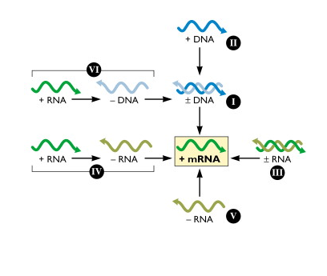
B
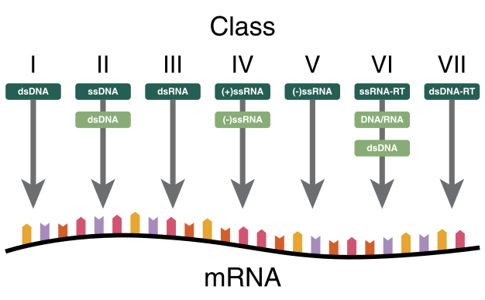

Fig. 1. Baltimore classification and its basis. A, from Flint et al., 2015, Principles of Virology, 4th Edition, Chapter 1, p. 21, after Fig. 1 in Baltimore, Bact. Rev. 1971, 35:235-241). B, from Wikipedia. Note that the name abbreviations of RNA virus classes differ in panels A and B, and also from those used in the text.

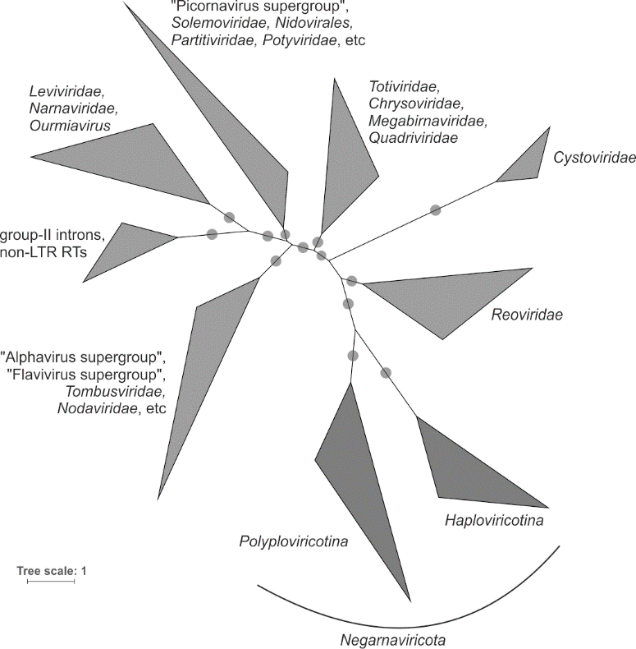

Fig. 2. Global RNA virus phylogenetic tree based on a complete alignment of the conserved polymerase palm (core) domains in a non-redundant (at ≈90% identity level) set of ≈5,000 RNA-dependent RNA polymerases of positive-sense RNA viruses, negative-sense RNA viruses, and dsRNA viruses as well as reverse transcriptases from group II bacterial introns and non-LTR retroelements. An approximate Maximum Likelihood tree was constructed using FastTree with the WAG evolutionary model and gamma-distributed site rates. Circles represent bootstrap branch supports higher than 0.9. The tree is adapted from Wolf et al. [18].

1. Baltimore D (1971) Expression of animal virus genomes. BacteriolRev 35:235-241
2. Bruenn JA (1991) Relationships among the positive strand and double-strand RNA viruses as viewed through their RNA-dependent RNA polymerases. Nucleic Acids Research 19:217-226
3. Coulibaly F, Chevalier C, Gutsche I, Pous J, Navaza J, Bressanelli S, Delmas B, Rey FA (2005) The birnavirus crystal structure reveals structural relationships among icosahedral viruses. Cell 120:761-772
4. Delarue M, Poch O, Tordo N, Moras D, Argos P (1990) An attempt to unify the structure of polymerases. Protein Engineering 3:461-467
5. Gorbalenya AE (1995) Origin of RNA viral genomes; Approaching the problem by comparative sequence analysis. In: Gibbs AJ, Calisher CH, Garcia-Arenal F (eds) Molecular Basis of Virus Evolution. Cambridge University Press, Cambridge, UK, pp 49-66
6. Gorbalenya AE, Pringle FM, Zeddam JL, Luke BT, Cameron CE, Kalmakoff J, Hanzlik TN, Gordon KH, Ward VK (2002) The palm subdomain-based active site is internally permuted in viral RNA-dependent RNA polymerases of an ancient lineage. Journal of Molecular Biology 324:47-62
7. Gorbalenya AE (2018) Increasing the number of available ranks in virus taxonomy from five to ten and adopting the Baltimore classes as taxa at the basal rank. Arch Virol 163:2933-2936
8. Jacome R, Becerra A, de Leon SP, Lazcano A (2015) Structural analysis of monomeric RNA-dependent polymerases: evolutionary and therapeutic implications. Plos One 10:e0139001
9. Kamer G, Argos P (1984) Primary structural comparison of RNA-dependent polymerases from plant, animal and bacterial-viruses. Nucleic Acids Research 12:7269-7282
10. Koonin EV, Dolja VV (1993) Evolution and taxonomy of positive-strand RNA viruses: implications of comparative analysis of amino acid sequences [published erratum appears in Crit Rev Biochem Mol Biol 1993;28(6):546]. Critical Reviews in Biochemistry and Molecular Biology 28:375-430
11. Koonin EV, Dolja VV, Krupovic M (2015) Origins and evolution of viruses of eukaryotes: The ultimate modularity. Virology 479:2-25
12. Krupovic M, Koonin EV (2017) Multiple origins of viral capsid proteins from cellular ancestors. Proceedings of the National Academy of Sciences of the United States of America 114:E2401-E2410
13. Lang DM, Zemla AT, Zhou CLE (2013) Highly similar structural frames link the template tunnel and NTP entry tunnel to the exterior surface in RNA-dependent RNA polymerases. Nucleic Acids Research 41:1464-1482
14. Monttinen HAM, Ravantti JJ, Poranen MM (2016) Common structural core of three-dozen residues reveals intersuperfamily relationships. Molecular Biology and Evolution 33:1697-1710
15. Poch O, Blumberg BM, Bougueleret L, Tordo N (1990) Sequence comparison of 5 polymerases (L-Pproteins) of unsegmented negative-strand RNA viruses - theoretical assignment of functional domains. Journal of General Virology 71:1153-1162
16. Shi M, Lin XD, Tian JH, Chen LJ, Chen X, Li CX, Qin XC, Li J, Cao JP, Eden JS, Buchmann J, Wang W, Xu JG, Holmes EC, Zhang YZ (2016) Redefining the invertebrate RNA virosphere. Nature 540:539-545
17. Vieth S, Torda AE, Asper M, Schmitz H, Gunther S (2004) Sequence analysis of L RNA of Lassa virus. Virology 318:153-168
18. Wolf YI, Kazlauskas D, Iranzo J, Lucía-Sanza A, Kuhn JH, Krupovic M, Dolja VV, Koonin EV, (2018) Origins and evolution of the global RNA virome. MBio in press

